Topics: Confidence Intervals

- For each of the following statements, indicate whether it is True/False. If false, explain why.

- The sample size of the survey should at least be a fixed percentage of the population size in order to produce representative results.

- The sampling frame is a list of every item that appears in a survey sample, including those that did not respond to questions.

- Larger surveys convey a more accurate impression of the population than smaller surveys.
Answer:
- False, not every time we can have a fixed percentage of a population size. Sometimes, even small sample size provides representative results of the given population.
- False, the sampling frame is a list of every item in the population that is eligible to be included in the sample. It does not include items that did not respond to questions.
- True.

- PC Magazine asked all of its readers to participate in a survey of their satisfaction with different brands of electronics. In the 2004 survey, which was included in an issue of the magazine that year, more than 9000 readers rated the products on a scale from 1 to 10. The magazine reported that the average rating assigned by 225 readers to a Kodak compact digital camera was 7.5. For this product, identify the following:

- The population
- The parameter of interest
- The sampling frame
- The sample size
- The sampling design
- Any potential sources of bias or other problems with the survey or sample

Answer:

- The population – The entire readers of PC Magazine will be the population size

- The parameter of interest – Here the parameter of interest is the average rating assigned by readers to Kodak compact digital camera.

- The sampling frame – The sampling frame is the source from which the sample is drawn. Therefore, here the sampling frame will the readers of PC Magazine who received the survey and took part to rate the product.

- The sample size – 225 is the given sample size who rated the Kodak compact digital camera.

- The sampling design - It is Convenience sampling because the readers who chose to participate in the survey were not randomly selected.

- Any potential sources of bias or other problems with the survey or sample – It is based on convenience sampling where the readers who rated the products were not selected randomly. Also, the data is based on self-reported ratings, which could be biased and does not represent the entire population.

- For each of the following statements, indicate whether it is True/False. If false, explain why.

- If the 95% confidence interval for the average purchase of customers at a department store is $50 to $110, then $100 is a plausible value for the population mean at this level of confidence.

- If the 95% confidence interval for the number of moviegoers who purchase concessions is 30% to 45%, this means that fewer than half of all moviegoers purchase concessions.

- The 95% Confidence-Interval for μ only applies if the sample data are nearly normally distributed.

Answer:

- True
- False – The given statement provides 95% confidence interval of the moviegoers who purchase concessions 30% to 45%. This doesn’t provide the exact proportion of the people who purchase concessions. It can be less than 50% or even greater than 50%.

- False - The 95% confidence interval for the population mean μ applies even if the sample data are not normally distributed. This is because the central limit theorem states that the distribution of the sample mean will be approximately normal, even if the population distribution is not normal, as long as the sample size is sufficiently large.

- What are the chances that ?

- ¼
- ½
- ¾
- 1

Answer- B

- In January 2005, a company that monitors Internet traffic (WebSideStory) reported that its sampling revealed that the Mozilla Firefox browser launched in 2004 had grabbed a 4.6% share of the market.

- If the sample were based on 2,000 users, could Microsoft conclude that Mozilla has a less than 5% share of the market?

- WebSideStory claims that its sample includes all the daily Internet users. If that’s the case, then can Microsoft conclude that Mozilla has a less than 5% share of the market?
Answer:

- If the sample were based on 2,000 users, could Microsoft conclude that Mozilla has a less than 5% share of the market?

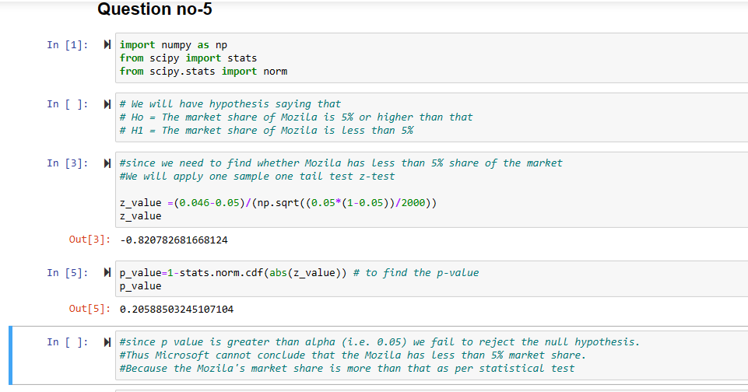

The above code clearly reflects that the p value is greater tha alpha (0.05). Hence we fail to reject the null. Which indicates that the market share of Mozila is greater than 5%.

- WebSideStory claims that its sample includes all the daily Internet users. If that’s the case, then can Microsoft conclude that Mozilla has a less than 5% share of the market?

If WebSideStory claims that its sample includes all the daily internet users, and the sample proportion is 4.6%, then it implies that this proportion represents the entire market. And Microsoft can conclude that Mozilla has a less than 5% share of the market.

- A book publisher monitors the size of shipments of its textbooks to university bookstores. For a sample of texts used at various schools, the 95% confidence interval for the size of the shipment was 250 ± 45 books. Which, if any, of the following interpretations of this interval are correct?

- All shipments are between 205 and 295 books.

- 95% of shipments are between 205 and 295 books.

- The procedure that produced this interval generates ranges that hold the population mean for 95% of samples.

- If we get another sample, then we can be 95% sure that the mean of this second sample is between 205 and 295.

- We can be 95% confident that the range 160 to 340 holds the population mean.
Answer:

C – is the correct interpretation.

The statement interprets that, the 95% confidence interval is constructed in such a way that if I have to consider many random samples and build a confidence interval for each sample, then approximately 95% of those intervals would contain the true population mean.

- Which is shorter: a 95% z-interval or a 95% t-interval for μ if we know that σ =s?

- The z-interval is shorter
- The t-interval is shorter
- Both are equal
- We cannot say

Answer: A – The Z-interval is shorter
A z-interval is used when the population standard deviation is known. A t-interval is used when the population standard deviation is unknown and the sample size is small (n < 30).
Hence, t-distribution produces wider intervals compared to the z-distribution because it accounts for the additional uncertainty associated with estimating the population standard deviation from the sample. In contrast, the z-distribution assumes that we know the population standard deviation and therefore produces narrower intervals.

Questions 8 and 9 are based on the following: To prepare a report on the economy, analysts need to estimate the percentage of businesses that plan to hire additional employees in the next 60 days.

- How many randomly selected employers (minimum number) must we contact in order to guarantee a margin of error of no more than 4% (at 95% confidence)?

- 600
- 400
- 550
- 1000

Answer: A - 600

To determine the minimum number of randomly selected employees, we use the following formula

n = (Z^2 * p * (1-p))/e^2

- n is the sample size
- z is the critical value for the desired confidence level (1.96 for 95% confidence)
- p is the estimated proportion of businesses that plan to hire additional employees (we can assume 0.5 since we don't have any prior information)
- e is the desired margin of error (0.04)

n = ((1.96)^2 *0.5 * (1-0.5)) / 0.04^2
n = (3.84 * 0.5 * 0.5 )/0.0016
n= 600 s

- Suppose we want the above margin of error to be based on a 98% confidence level. What sample size (minimum) must we now use?

- 1000
- 757
- 848
- 543

Answer: C – 848

We will use the same above formula (which we used in question no-8) to find the sample size. But the Z value will now change to 2.33 with 98% confidence interval.

n = (Z^2 * p * (1-p))/e^2

n = ((2.33)^2 *0.5 * (1-0.5)) / 0.04^2
n = (5.42 * 0.5 * 0.5 )/0.0016
n= 846.875 - which is proximate to option C – 848

